Internship Report - Day 6
Name : Rickshtiha A
Intern ID : CDM/INT/202607608
Topic: Data Visualization using Matplotlib

Objective
The objective of Day 6 was to learn the basics of data visualization using the Matplotlib library. The session focused on creating scatter plots, bar charts, and line charts to visualize data and understand trends, comparisons, and relationships.

Tasks Completed
- Installed and imported Matplotlib.
- Loaded the student score dataset.
- Created a line chart.
- Created a bar chart.
- Created a scatter plot.
- Added chart title, labels, and grid.
- Learned the importance of data visualization.

Introduction to Matplotlib
Matplotlib is a Python library used for creating graphs and charts. It helps represent data visually, making it easier to identify trends, patterns, and comparisons.
Advantages of Matplotlib
- Easy to create charts
- Supports different graph types
- Helps analyze data visually
- Widely used in Data Science and Machine Learning

Dataset
Create a file named student_scores.csv
Name | Maths | Science | English
Asha | 85 | 90 | 88
Rahul | 78 | 82 | 80
Priya | 92 | 95 | 94
Arun | 74 | 70 | 72
Divya | 89 | 91 | 90

Program 1 – Line Chart
import pandas as pd
import matplotlib.pyplot as plt

df = pd.read_csv("StudentsPerformance.csv")

plt.plot(df.index[:20], df["math score"][:20], marker='o')

plt.title("Math Scores of First 20 Students")
plt.xlabel("Student Index")
plt.ylabel("Math Score")

plt.grid(True)

plt.show()

Program 2 – Bar Chart
import pandas as pd
import matplotlib.pyplot as plt

df = pd.read_csv("StudentsPerformance.csv")

avg_math = df.groupby("gender")["math score"].mean()

plt.bar(avg_math.index, avg_math.values)

plt.title("Average Math Score by Gender")
plt.xlabel("Gender")
plt.ylabel("Average Math Score")

plt.show()
Program 3 – Scatter Plot
import pandas as pd
import matplotlib.pyplot as plt

df = pd.read_csv("StudentsPerformance.csv")

plt.scatter(df["math score"], df["reading score"])

plt.title("Math Score vs Reading Score")
plt.xlabel("Math Score")
plt.ylabel("Reading Score")

plt.show()
Concepts Learned
Line Chart
- Shows trends over data.
- Useful for comparing values over an ordered sequence.
Bar Chart
- Compares values between different categories.
- Easy to identify the highest and lowest values.
Scatter Plot
- Shows the relationship between two numerical variables.
- Helps identify patterns or correlations.
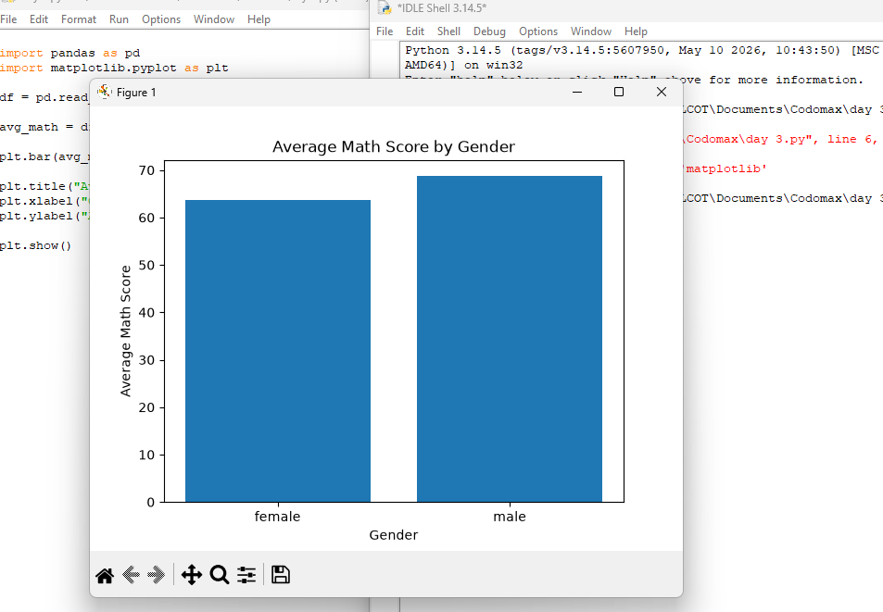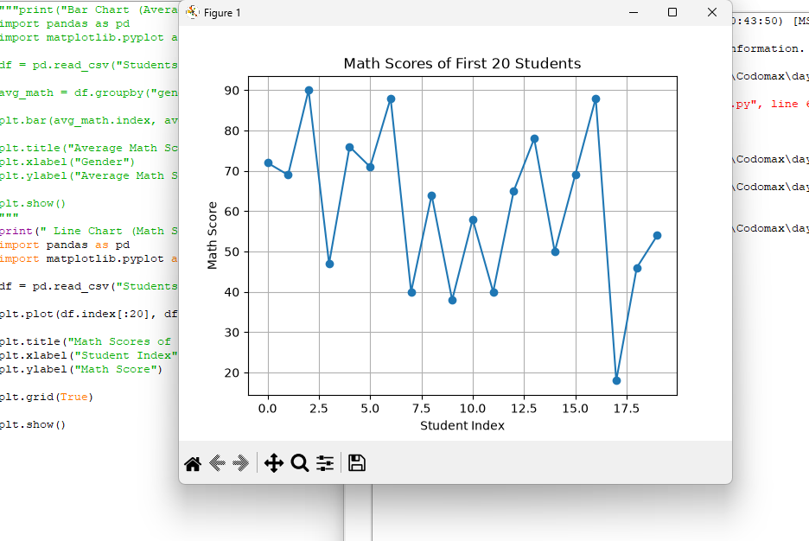

Applications of Data Visualization
- Data Analysis
- Machine Learning
- Business Reports
- Sales Analysis
- Financial Analysis
- Scientific Research
- Artificial Intelligence

Expected Outcome
- Successfully created a line chart, bar chart, and scatter plot.
- Learned how to visualize data using Matplotlib.
- Understood the importance of graphical representation in data analysis.

Learning Outcome
On Day 6, I learned how to use the Matplotlib library to create basic data visualizations. I created line charts, bar charts, and scatter plots using a student score dataset. These visualizations helped in understanding data trends, category-wise comparisons, and relationships between variables. Data visualization is an essential step in data analysis and machine learning.

